

**Progress Report No. 1**

**Integrated Project**

**Course Code ASP3101**

**PROJECT TITLE**

**To make a solar mobile charger**

**SUBMITTED TO: SUBMITTED BY:**

Mrs. Pooja Dhiman SARTHAK CHAWLA 1611981336

ANMOL WADHAWAN 1611981462

**Abstracts**

With fuel hikes making news, solar energy is the most sought after energy source. Solar chargers are simple, portable and ready to use devices which can be used by anyone especially in remote areas. Going solar can solve more than one problems, right from cutting down on carbon emissions and dependence on fuels, to solving the energy crisis. This project aims to make a simple solar charger which can be used on the go. Solar panels don’t supply regulated voltage while batteries need so for charging. Hence, an external adjustable voltage regulator is used to have the desired constant voltage. A zener diode switches on to ensure charging is cut off at the saturation point.

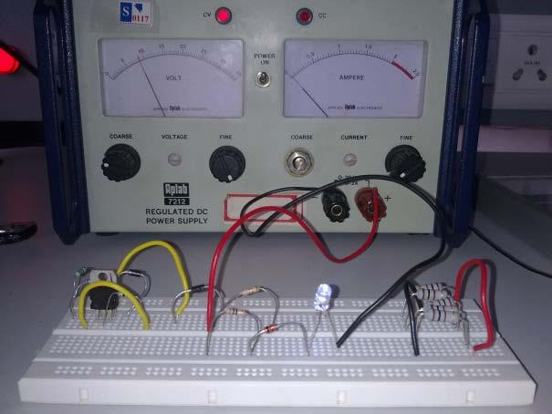

*Fig1: Illustrative diagram of solar mobile charger*

**Introduction**

Gone are the days when you would look up at the Sun and curse yourself for being out on a hot sunny day. Take pride; very soon you will be a walking energy station with people asking you to help them charge their batteries with your clothes. This isn’t a scene out of a Sci-Fi movie. It is the simple application of solar cells. They are the only way we can convert sunlight into electricity directly and day by day they are getting better, smaller and cheaper. Nothing can dare challenge the sun when it comes to radiating energy. Every hour the energy available from the sun is more than what human’s require for an entire year. Petrol, diesel and all these fossil fuels are nothing but sun’s energy concentrated over years and years. This makes them very efficient in terms of energy per unit of the fuel. Solar energy isn’t something new. People have used sun to dry and preserve things. Vedic literatures in India even state the use of flying machines which were powered using the sun. Come 21st century, we have come a long way in developing solar cells which are the devices powering our future, converting sun’s energy into electricity. Solar panels are simply solar cells lined up together in series and parallel so as get sufficient voltage and are p-n junction semiconductor devices with pure silicon wafer doped with ‘n’ type phosphorous on the top and ‘p’ type boron on the base. If the PV cell is placed in the sun, photons of light strike the electrons in the p-n junction and energize them, knocking them free of their atoms. These electrons are attracted to the positive charge in the n-type silicon and repelled by the negative charge in the p-type silicon. Connecting wires across the junction will have a current in them.

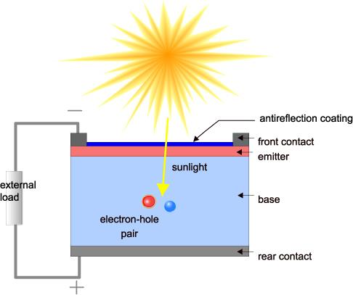

*Fig2: Working of solar panel*

Solar cells have come a long way from bulky 6% efficient chunks to thin films with as much as 30% efficiency. They are selling like hot cakes today given their necessity and utility. And the reason being they are faithful good chaps unlike oil which will soon be more precious to us than diamonds and the black monster: coal which has polluted the air, hand in cuff with the other fossil fuels. We need to understand solar panels so as to understand their applications. Today, we have monocrystalline, polycrystalline and amorphous thin film panels. Mono-crystalline are so far the most efficient, given that they have the maximum silicon in a unit area so more current for the same number of photons. They are made out of a single silicon crystal as a continuous lattice. While for the polycrystalline panels, molten silicon is poured into molds and separate boundaries can be seen due to this. Lesser quantity of silicon in a unit area means lesser efficiency of production of electricity. Amorphous thin film panels are layers of silicon on a glass surface and are the least expensive. Hence, they are used in applications where you can do away with efficiency for lowering the costs. Solar panels are really useful in broad daylight but we need energy when the Sun isn’t shining above our rooftops. That’s why we need solar chargers which will store energy in rechargeable batteries. This project aims to make a solar charger using a voltage regulator IC so as to charge a Lead Acid Battery with the constant output voltage obtained through this IC LM317( Details explained later). Today there are many more options like a SOLAR CHARGER IC LT3652. This is an IC with embedded MPPT (Maximum Power Point Tracking) algorithm. MPPT simply means the IC gets the maximum possible power from the solar panel by sampling its output and applying the proper load resistance. This small chip simplifies life given its ease of use and maximum efficiency is always ensured. Even 15% efficient solar panels installed across the world’s wastelands can produce enough clean energy to sustain mankind for a year.

**Developments in this field**

Yet new technology is continuously being developed though solar energy generation is still in its infancy. The concept of SOLAR FARMING is new and catching up fast in investors. India is a tropical country and can soon become the Saudi Arabia of solar energy. With Concentrated Photo Voltaic (CPV : which increase efficiency by concentrating large amount of sunlight on the solar cells using mirrors) coming up in India, we are definitely headed towards a cleaner future. Reducing dependence on fossil fuels and cutting down on our carbon emissions is one of the most important aspects of solar energy. With ambitious project like the National Solar missions aiming at producing 20GW (India’s energy consumption 2012: 100GW out of which 1GW was Solar energy) by 2020 is a big step toward progress. Rural areas are now lit up with solar lamps. Solar parks are also an emerging trend with Charanka Solar Park, Gujarat producing 20MW of energy. Government is also taking initiatives to encourage people to make use of the sun by subsidizing electricity bills for consumers using the solar panels. So if you make more energy than you use, you will end up in a profit without even burning a calorie. Going Solar is exciting but some challenges also need to be addressed. Renewable sources of energy alone can ensure sustainable development. Economic growth can also be ensured by energy reaching to each and every household in turn increasing the productivity of industries andstandard of living of people. It is a bright future we have ahead of us; the only thing is we need to focus the glare rather than evading it.

**Theory**

This project aims to make a solar charger circuit using IC LM 317 which is an adjustable voltage regulator.

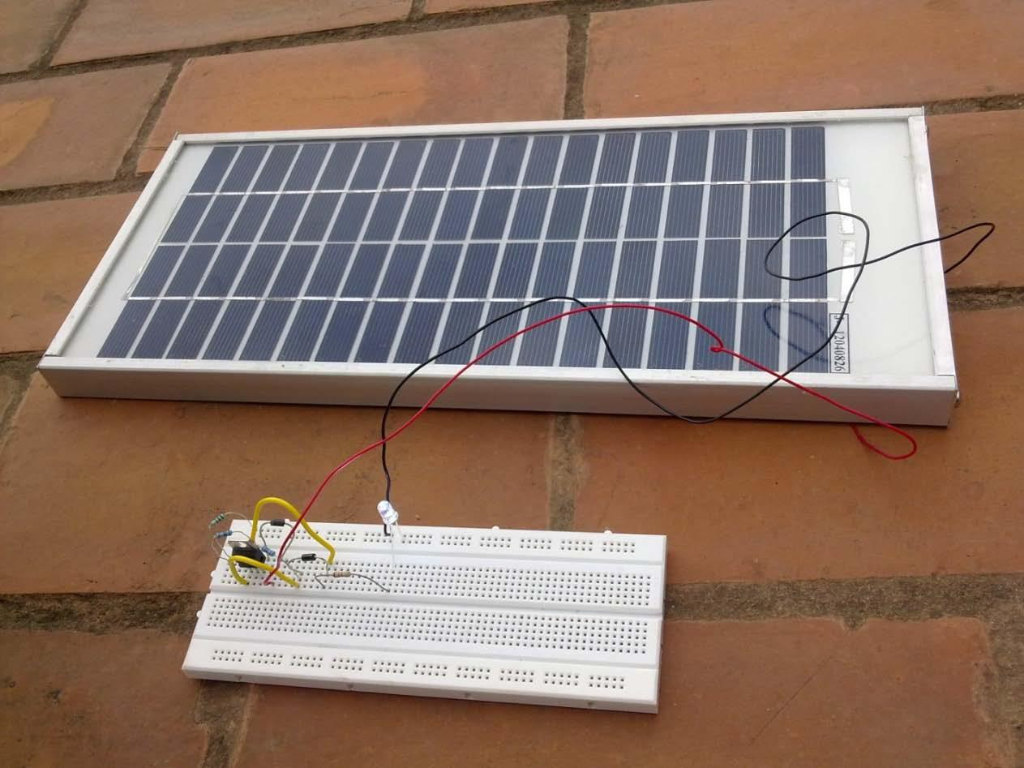

*Fig 3:* *Depicted model along with circuit*

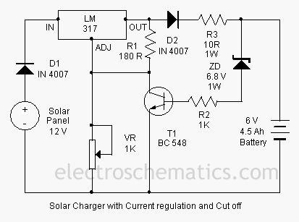

*Fig 4:*

This solar charger then charges a Lead acid battery which in turn will power our solar lamp.

**Components Involved:**

• **Solar Panel:** The heart of the circuit. It has the following specifications: i) Voc= 17.4V ii) Isc= 0.33A iii) Vmp= 17.4V iv) Max Power= 5W

This is our power supply. It is responsible for charging the battery.

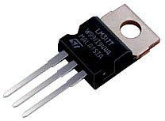

*Fig5: IC LM317*

• It is an adjustable voltage regulator IC which means it provides Line Regulation (irrespective of the changes in the input voltage, the output voltage remains constant) and Load Regulation (irrespective of the changes in load the output voltage is fixed). We can adjust the output voltage by varying the resistance across the adjust pin. This is needed to have a fixed voltage across the battery (to limit the current and charge it at constant voltage). Directly connecting the solar panel to the battery may even explode it due to the varying output from it. The voltage across R1 is maintained to be 1.25 V using an internal circuit. The Vout is also then obtained to be constant and given by: Vout = VR1*(1+R2/R1)+Iadj*R2. This Iadj is of the order of microA so can be neglected to have a regulated output voltage.

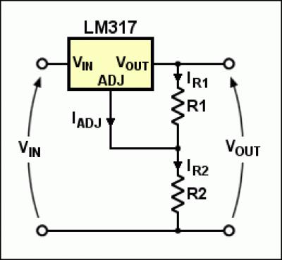

*Fig 6:Working layout of IC LM317*

• **Battery:** (SEALED LEAD ACID BATTERY): This circuit is designed for a 6V, 5Ah battery. This means a 5A current will charge the battery in 1hour. Lead acid batteries are not the best available options in rechargeable batteries (unlike portable and easy to use Li-ion batteries). But for small applications like our solar lamp, they are good enough. Care must be taken while handling acid battery.

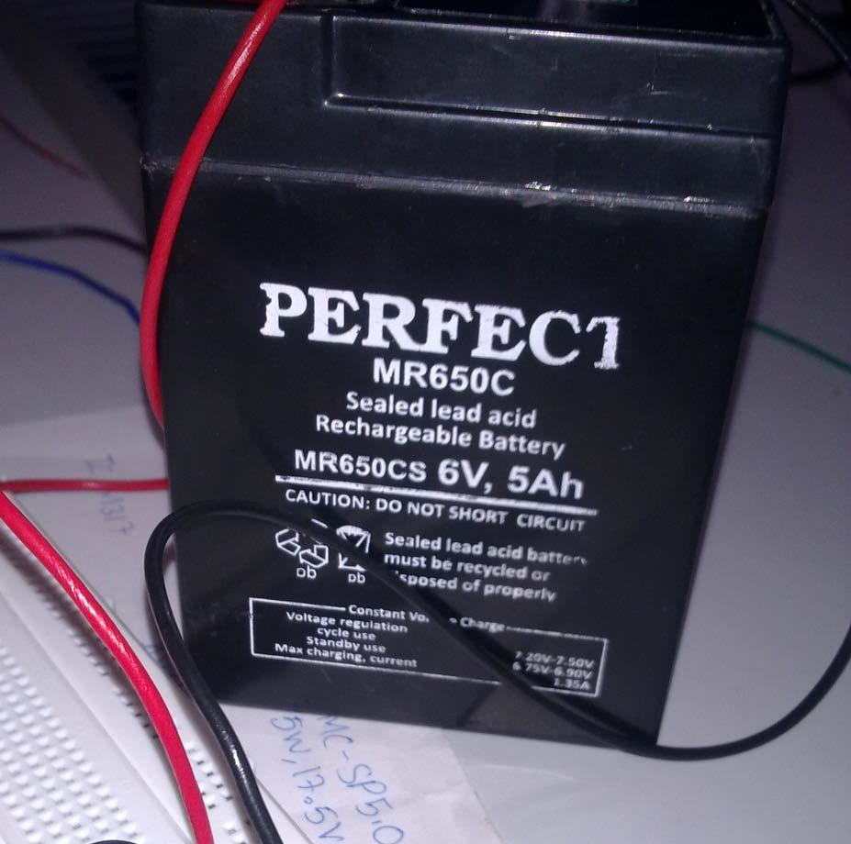

*Fig7:Battery*

• **Diodes(1N5812):** These are simply blocking diodes which ensure that the current flows only in one way so that the battery doesn’t discharge when the output from solar panel is low. • **Zener Diode(1N4736) and the Transistor(BC548):** This part of circuit ensures that once the charging cut off voltage is reached by the battery, the charging stops. The Zener is rated at 6.8V as breakdown. This allows all the voltage to drop across the Zener and the transistor switches on due to biasing of the Base-Emitter junction. The transistor acts like a switch and once the battery is charged, it draws all the current thus protecting the battery.

**Bibliography**

www.main.org/polycosmos/glxywest/vimanas.htm - Indian Flying Machines

http://www.triplepundit.com/2011/08/solar-farming-potential-india/ - Solar Farming

<http://www.planetarypower.com.au/solar_panels.htm>

http://www.earthtimes.org/energy/solar-cells-future/1403/

Element14 – to look up devices, ICs

Physics of Solar Cells- A Text for Undergraduates, J Nelson